Assignement 2

ESE – 3005

EMBEDDED SYSTEMS ARCHITECTURE 2

Submitted to :

Linchan Wang

Submitted by:

Gurvinder Singh(748418)

1. create a service file:

(i)sudo cp/lib/systemd/system/cron.service/lib/systemd/system/sleep.service

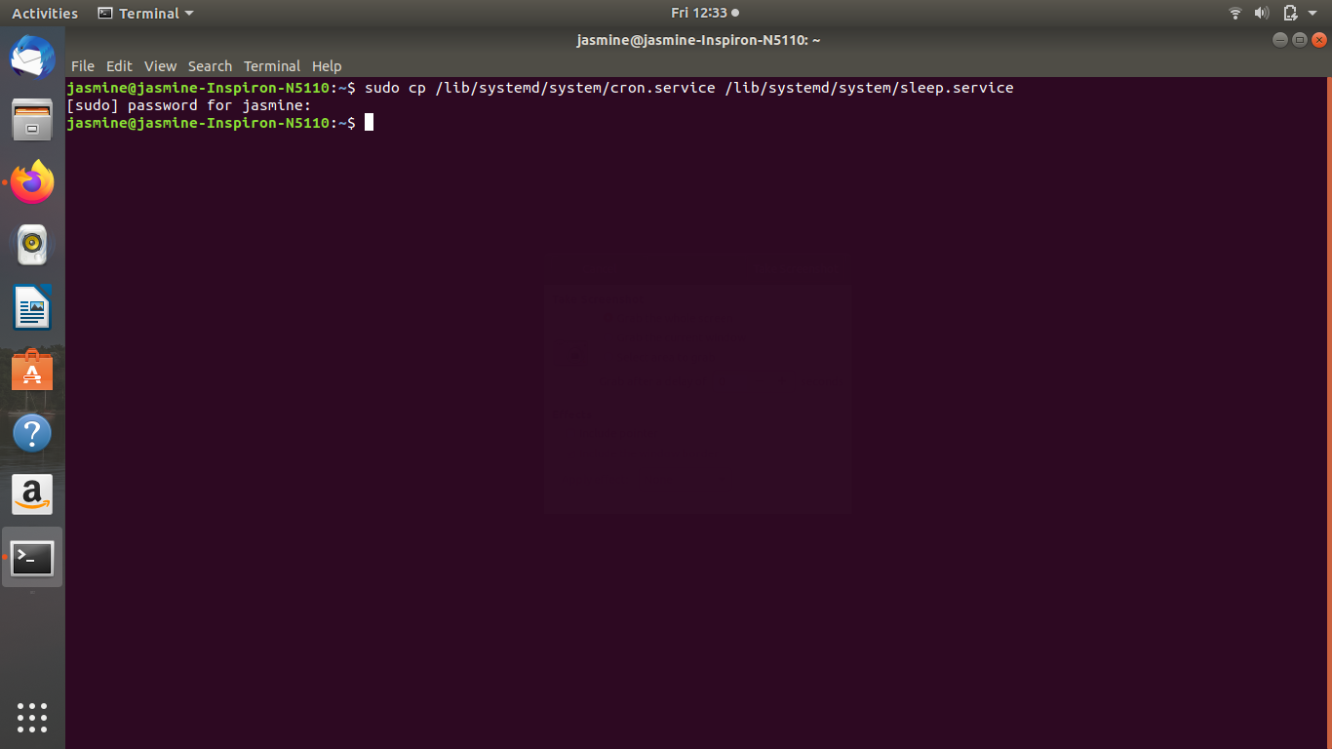(ii)sudo nano /lib/systemd/system/sleep.service

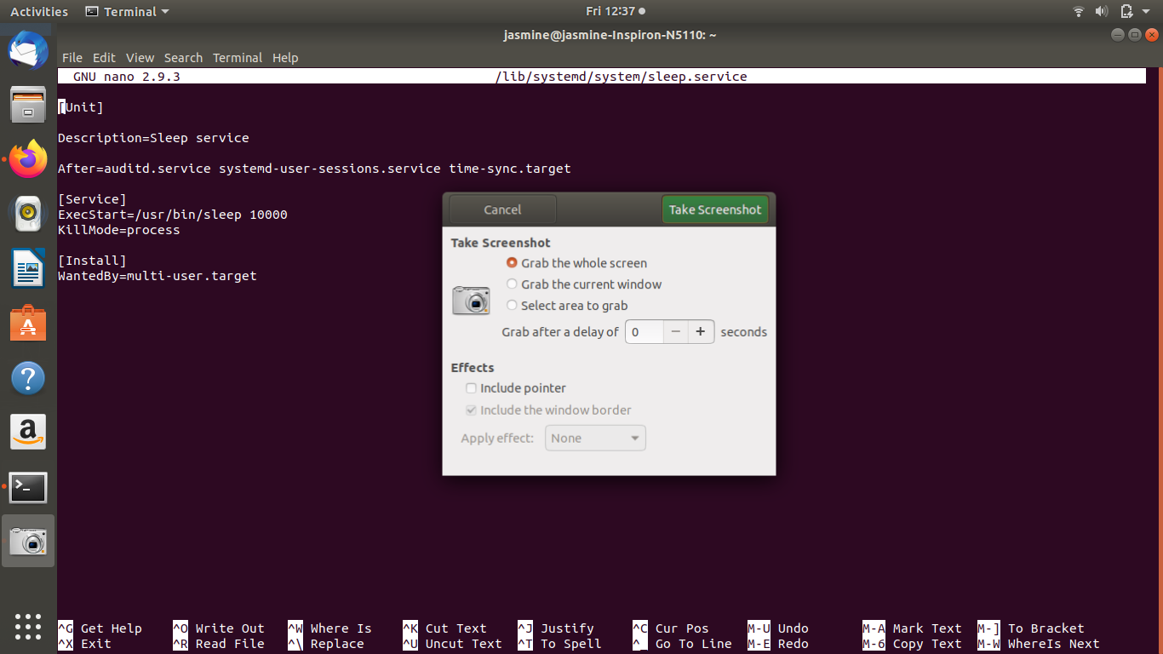

2.(a)enable the service

systemctl enable sleep.service

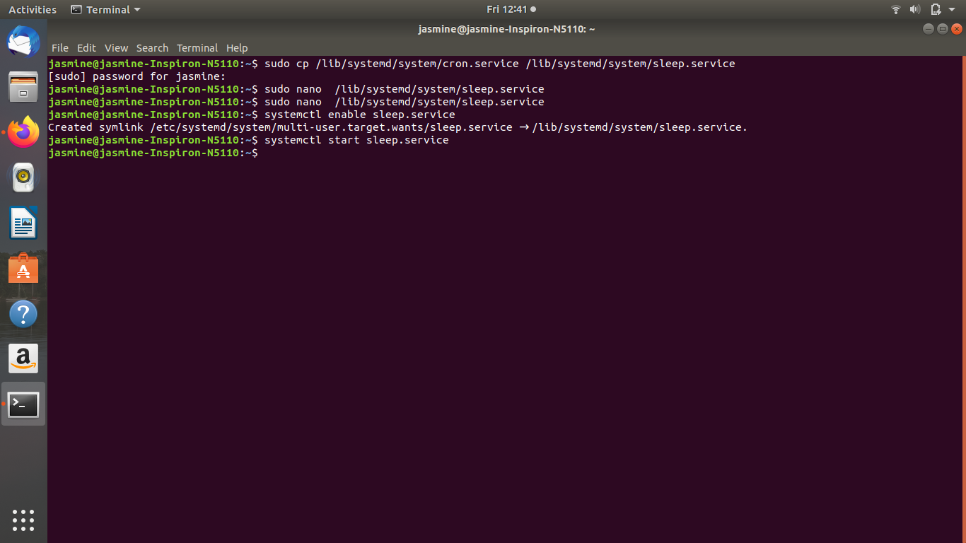

(b)start the service

systemctl start sleep.service



(c)check status

systemctl status sleep.service

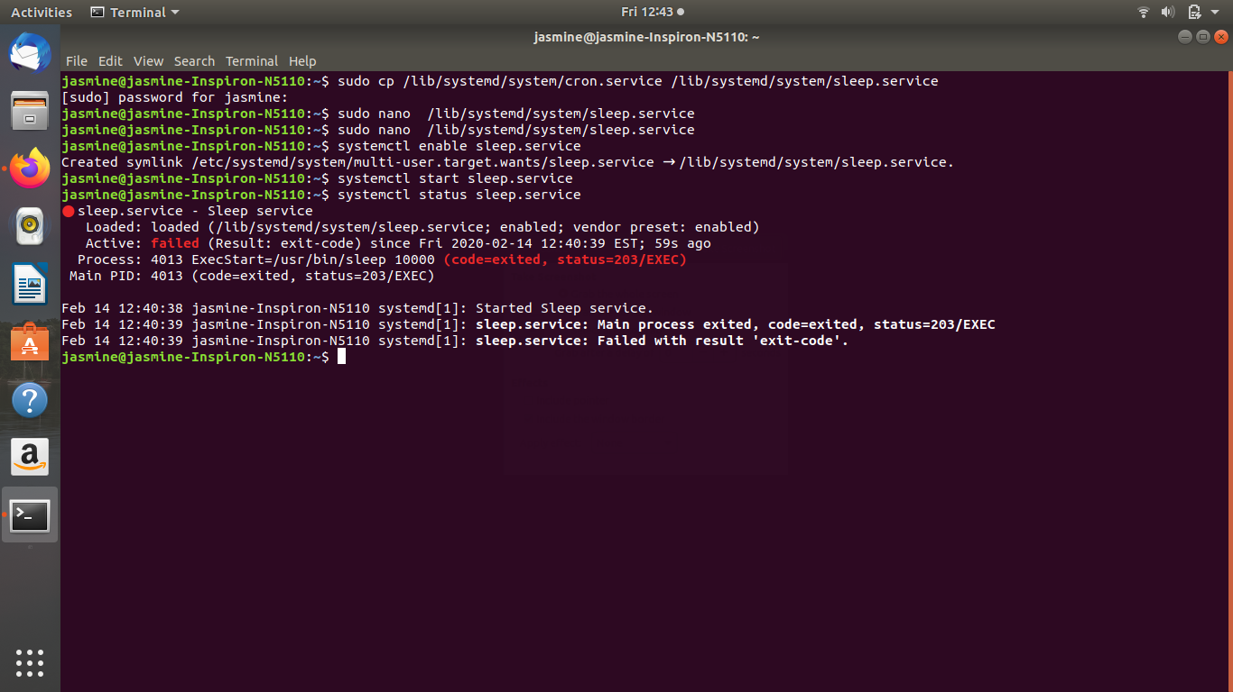(d)stop and disable the service

systemctl stop sleep.service; systemctl disable sleep.service

